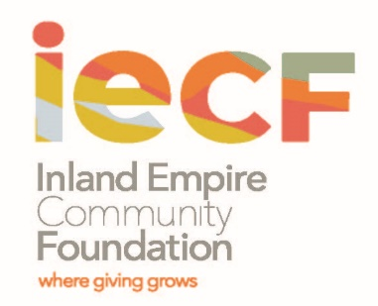 | 2024 Field of Interest Funds  Grant Guidelines & Instructions  Deadline: April 15, 2024  (

Mission of the Inland Empire Community Foundation
The mission of the Inland Empire Community Foundation is to enhance the quality of life in the communities we serve. This is accomplished through building permanent endowments, making prudent grants for charitable causes, being a catalyst to solve community concerns and strengthening nonprofit organizations.

Eligibility
- Nonprofit, public benefit corporations with evidence of tax-exempt status under Section 501(c) (3) of the Internal Revenue Code and not classified as a private foundation. Public agencies (in limited circumstances) may apply.
- Nonprofit organizations that can document on-going operations in Riverside and/or San Bernardino Counties and have nonprofit status per above for at least three years.
- Past grantees must be in good standing, and have fulfilled all previous grant obligations.

Field of Interest Funds
Field of Interest funds are restricted to a specific program area or geographic area. Those restrictions are made by the fund donors. The size of the grants varies based on the asset size of each fund. When a field of interest fund benefits a specific community, a local advisory committee may be asked to review grant proposals and make funding recommendations.

The current Field of Interest funds are:
- Irene S. Rockwell Fund - Benefits the residents of the city of Perris. Maximum grant per organization is $5,000.
- Seraphim Fund - Aids women and children, including the economically disadvantaged, victims of domestic abuse, and those suffering from physical or mental illness or substance abuse. Maximum grant per organization is $10,000
- Fred and Eva V. Stebler Fund - Provides funds for the treatment and care of indigent children in Riverside County, with a strong emphasis on children with special needs. Maximum grant per organization is $10,000.
- James Bernard and Mildred Jordan Tucker Fund - Benefits wheelchair users (ADA compliance projects are eligible). Maximum grant per organization is $10,000.

Grant making Objectives
- Maximize resources and efficiency through collaboration
- Promote values of personal responsibility and self-sufficiency
- Increase community involvement and volunteerism
- Support early intervention and prevention of social problems

Funding Priorities
Organizations that:
- Have its mission, goals and programming address the critical needs of individuals and communities most impacted by racial, gender and economic inequity due to their race, income level, gender, religion, immigration status, disability, age, sexual orientation or zip code;
- Provide programs, services and core activities that are culturally and linguistically responsive to the needs of those served;
- Demonstrate strong, community-based boards and sound financial practices.
- Collaborate or partner with other non-profit entities resulting in greater community impact and positive outcomes that improve, enhance, and enrich the quality of life in the two-county area, as appropriate.

Preference is given to projects that:
- are perceived as a high need in the community being served.
- fill a gap in service.
- benefit a large number of residents.
- enhance collaboration and/or make the delivery of services more effective and efficient.
- have clear objectives and can document successful outcomes.
- expand successful programs to serve additional residents or new geographic areas
- serve remote areas or areas that have received little Community Foundation funding.

Grant Period
The grant period is for one year, starting July 1, 2024 to June 30, 2025.

Limitations
These types of expenses are not eligible for funding:
- on-going operating expenses | - paying off deficits or existing obligations
- retroactive funding for costs already incurred | - endowment, capital or annual fund appeals
- capital projects (construction of buildings) | - sectarian programs or fraternal organizations
- direct support of individuals | - school/college-based extracurricular activities
- research or development activities | - partisan activities
- event sponsorships | - re-granting purposes

Application Review
Grants are awarded on a competitive basis. Applications will be screened for eligibility and completeness by the Inland Empire Community Foundation (IECF) staff. The IECF Grant Committee will evaluate eligible applications and will forward grant recommendations to the Inland Empire Community Foundation Board of Directors for final approval. All applicants will be notified of the results in writing by June 30, 2024.

