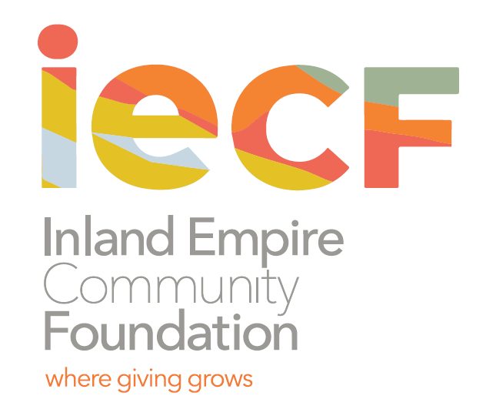

Contact: Charee Gillins FOR IMMEDIATE RELEASE

951.241.7777 February ?, 2021

cgillins@iegives.org

www.iegives.org

**Youth Grantmakers are Accepting Proposals from Nonprofits**

**Supporting Youth in San Bernardino**

San Bernardino, CA – Are you a nonprofit serving youth through unique projects or programs? The Youth Grantmakers of the Inland Empire Community Foundation might help fund it.

The Inland Empire Community Foundation serving Riverside and San Bernardino Counties is now accepting applications for grants from the San Bernardino Youth Grantmakers Fund through March 5, 2021.

The San Bernardino Youth Grantmakers awards grants to nonprofits in San Bernardino for programs, projects and activities that support the well-being of youth and teens in the area. This year’s class consists of high school students from Aquinas High School, San Bernardino High School, Indian Springs High School, Citrus High School, San Gorgonio High School, and Pacific High School who review grant proposals, conduct nonprofit site visits and recommend grants for funding.

Started in 2009, the program was created to empower youth to address issues important to them by learning about and leading the grantmaking process. Not only do these young people become civically engaged, but better prepared for community leadership and more aware of the nonprofit sector.

“We want to help nonprofits in the San Bernardino area for programs, projects and activities that support the well-being of youth and teens,” said Yahaira Angulo, a participant of San Bernardino Youth Grantmakers.

To view grant guidelines, determine eligibility, and download a grant application, please visit the [Grant Guidelines](https://www.iegives.org/wp-content/uploads/2021/02/2021-YG-SB-Grant-Guidelines-Appl.pdf). For assistance, contact Denisha Shackelford, Youth Initiatives Manager, at 951.241.7777 or at dshackelford@iegives.org.

*About the Inland Empire Community Foundation (formerly The Community Foundation)*

*Founded in 1941, the Inland Empire Community Foundation is the oldest and largest community foundation in Inland Southern California. We partner with individuals, families and corporations to help them achieve their charitable goals. Since inception, we have given out over $100 million in grants and scholarships. For more information visit the IECF’s website at* [*www.iegives.org*](http://www.iegives.org/)*. Be a part of our conversation on Facebook, Twitter and LinkedIn.*

###