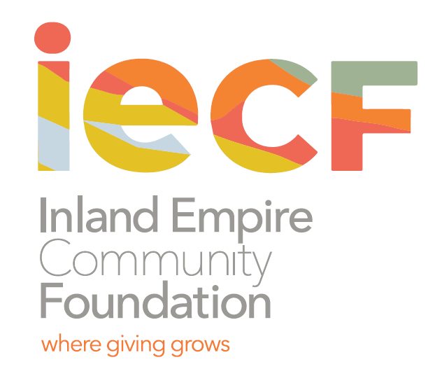

Contact: Charee Gillins FOR IMMEDIATE RELEASE
951.255.4254 January 12, 2021
cgillins@iegives.org
www.iegives.org

IECF Announces Winners of the Lift Up Local Program,
Awards $15,000 to Three IE Nonprofits

Riverside, CA – Inland Empire Community Foundation (IECF) announced today the winners of its “Lift Up Local” program. The program ran between November 27-December 31 and invited members of the community to support their favorite charity for a chance to win a $5,000 grant from IECF. In total, IECF awarded $15,000 in grants to three nonprofit organizations serving the Inland Empire.

The three grant recipients are:

Animal Friends of the Valleys, Lake Elsinore, CA ($5,000): Animal Friends of the Valleys is dedicated to promoting the humane care of animals through education and a humane, proactive animal services program. The organization is also committed to preventing the suffering of animals and to ending pet overpopulation in the communities they serve.

Steps 4 Life Community Services, Redlands, CA ($5,000): Steps 4 Life's mission is to empower individuals and families to receive the necessary training, education, and life-skills to re-enter society as positive individuals to community. Steps 4 Life serves many populations, including: veterans, homeless, domestic violence victims, those recovering from substance use and mental health disorders, victims of sex trafficking, and individuals who are re-integrating from the legal system.

Friends of the College of the Desert Library, Palm Desert, CA ($5,000): This organization promotes support for literature and libraries within the Coachella Valley and raises funds to benefit the College of the Desert Library.

The three winning organizations were selected through a random drawing. A combined total of 522 entries was submitted for the charities during the nomination period.

“As nonprofits continue to be impacted by the COVID-19 crisis, we are encouraged by the outpouring of support from the community and the 11,000 nominations we received through the Lift Up Local program,” said Michelle Decker, IECF CEO. “Congratulations to all three of the recipient organizations and thank you Inland Empire for showing so much love and care for our nonprofit community.”

About the Inland Empire Community Foundation
Founded in 1941, the Inland Empire Community Foundation is the oldest and largest community foundation in Inland Southern California. We partner with individuals, families and corporations to help them achieve their charitable goals. Since inception, we have given out over $100 million in grants and scholarships. For more information visit the IECF’s website at www.iegives.org. Be a part of our conversation on Facebook, Twitter and LinkedIn.
###

Photos:
Animal Friends of the Valley, Lake Elsinore, CA
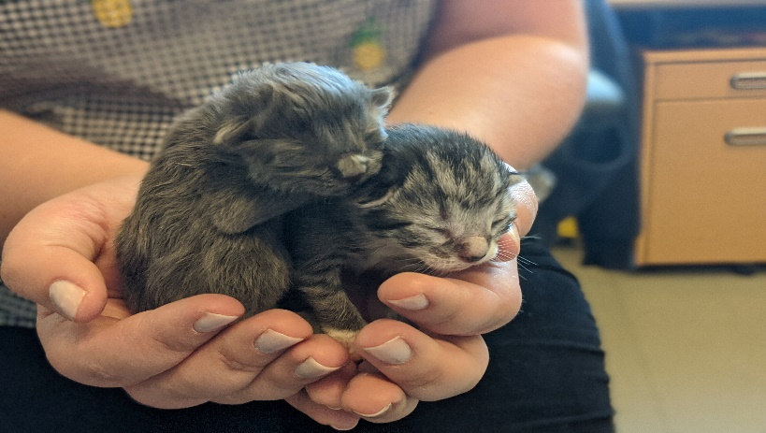
Steps 4 Life Community Services, Redlands, CA
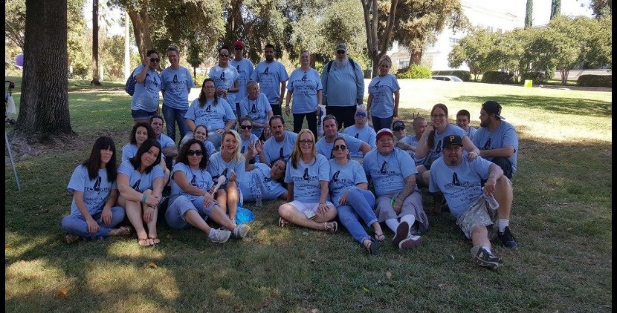
Friends of the College of the Desert Library, Palm Desert, CA
