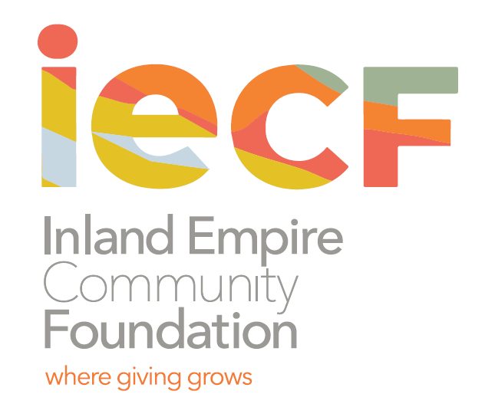
Contact: Charee Gillins FOR IMMEDIATE RELEASE
951.241.7777 February 26, 2021
cgillins@iegives.org
www.iegives.org

Inland Empire Community Foundation Opens 2021 Scholarship Program, Accepting Applications through May 3

Riverside, CA – Students from Riverside and San Bernardino counties are encouraged to apply for multiple scholarship programs at Inland Empire Community Foundation for the 2021-2022 school year. Deadlines for these scholarship opportunities range from March 19 through May 3. In 2020, over $4 million in scholarships and educational support were awarded to Inland students through IECF.

The Scholarship Program includes:

Riverside County:
Altura Credit Union Foundation Scholarship for graduating seniors in Riverside County; Reggie Edmond II Scholarship for students graduating from a school within the Riverside and Alvord Unified School District; James Buchner Memorial Scholarship for Hispanic/Latino students attending Cathedral High School; Desert Outreach Foundation Scholarship for students who reside in the Coachella Valley pursuing an undergraduate/graduate degree; Pavement Recycling, Inc. Scholarship for graduating seniors in the city of Riverside and neighboring cities; Riverside Construction Company/Harmon-Lounsbury Scholarship for Riverside students (high school seniors and first-year college) studying engineering, particularly in the area of construction or civil engineering; Dr. Barnett and Eleanor Jean Grier Advised Scholarship Fund for underrepresented and disadvantaged students in Riverside; Rosemarie Cionni-Mary Pastore Educational Trust Scholarship for students who graduated from Elsinore High School, Marvin Edward Leggett Jr. Endowed Fund for students graduating from Norte Vista High School and La Sierra High School in the Alvord Unified School District and The Beverly J. Soderling Scholarship Fund for graduating seniors at Banning High School.

San Bernardino County:
Dave & Mary Hjorth Family Endowment Fund Scholarship for graduating seniors of Upland High School pursuing a four-year college degree.

Both Counties:
Elizabeth C. and Jack B. Clarke. Sr. Endowed Scholarship Fund for African-American or Hispanic/Latino students residing in Riverside and San Bernardino; Ruth Schroff Scholarship Fund for African-American or Hispanic/Latino students residing in Riverside or San Bernardino Counties.

“These awards recognize student achievements and offer hope for those seeking to better themselves through education,” said Celia Cudiamat, Senior Vice President of Grants and Community Impact at IECF. “By providing scholarships to them, made possible by generous donors from the region, we are building a stronger future for the region.”

Scholarship amounts range from $1,000 - $4,750. For a full description of each of the scholarship programs, and to determine eligibility and apply, please visit www.iegives.org/scholarships.

Each Scholarship Program has its own application deadline. Deadlines range from March 19 through May 3.

Please contact Denisha Shackelford, Youth Initiatives Manager at 951-241-7777 or dshackelford@iegives.org for additional questions on any of the scholarship programs.

Founded in 1941, the Inland Empire Community Foundation is the oldest and largest community foundation in Inland Southern California. We partner with individuals, families and corporations to help them achieve their charitable goals. Since inception, we have given out over $100 million in grants and scholarships. For more information visit the IECF’s website at www.iegives.org. Be a part of our conversation on Facebook, Twitter and LinkedIn.

