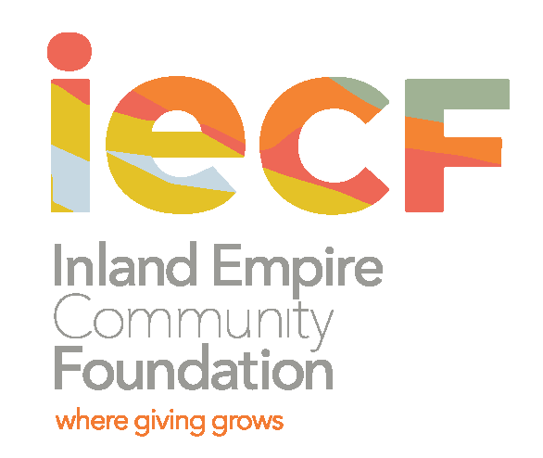

Request for Qualifications
Asset/Fund Development Organizational Consultant
Posted: December 15, 2020
About IECF
IECF is the longest-serving community foundation in the Inland Empire, serving Riverside and San Bernardino Counties, with a mission to “Strengthen the Inland Empire through philanthropy.” Established in 1941, IECF works with donors of all philanthropic amounts, stewards more than $100 million in assets, providing scholarships and grants to hundreds of students and nonprofit organizations. In March 2020, IECF’s Board of Directors adopted equity as a lens for its work, and two impact areas, educational equity and inclusive economic development. With new partnerships, fresh understandings of the critical issues in the Inland Empire, and an urgency to build the financial resources for change, IECF is putting renewed emphasis on its asset growth.
Also in 2020, IECF’s Board adopted an asset growth plan based on staff input, data analysis, and support from the consulting firm Sutherland Strategies. This plan outlines specific annual growth targets using on historic growth and priority fund types such as scholarships, DAFs, and Field of Interest funds. The fund development goal is growth from its current $104 million in assets to $150 million over 3 years. In support of that plan, IECF made a significant investment in growing its planned giving program through increased staffing and marketing the program to the community.
In the Inland Empire, charitable giving is historically lower than other areas of the state, and nonprofits struggle to serve their communities because of this. IECF feels a tremendous responsibility to raise dollars and align them with the needs of the communities it serves. Some of the most pressing needs include access to a quality education for the 1 million school children, assisting lower-wage workers with stable housing and access to other life-sustaining needs, and increasing educational opportunities for residents to improve their quality of life. IECF is a critical part of helping improve our region and raise the quality of life for those who live and work here.

Seeking a Consultant
Building on several years of significant program and organizational growth, IECF seeks a consultant to who can effectively design a structure its Charitable Giving Department and produce an operations plan for focused asset development efforts.
IECF projects a six month timeframe for this project. Elements of the project shall include:
- Working closely with the CEO, the Charitable Giving Team, and the Board Charitable Giving Committee to assess IECF’s status and capacity for meeting its goal and ongoing fundraising efforts;
- Identifying areas of strength and challenges across the whole organization to manage donors, gifts, and narrative;
- Helping IECF align all of its functional areas (grant making and programs, marketing and communications, finance and administration) to communicate IECF’s core mission and market its philanthropic tools and services;
- Connecting IECF staff and Board to best practices in the asset development field.
Deliverables
The most important deliverable requested is an effective, robust, and realistic operating plan for IECF asset growth from $104 million to $150 million over 3 years.
The expectation is that the elements of plan will include:
- A staffing plan for the Charitable Giving department;
- Protocols for moves management within Charitable Giving and across all IECF departments;
- A plan for creating a donor services function within IECF;
- Protocols for data use (including inputting and exporting data) from Foundant;
- Plan for prospect identification and engagement;
- Plan for aligning messaging and marketing with donor engagement and identification, stewardship and retention;
- Plan for Board engagement in asset development strategies;
- A roadmap with actions for successful plan implementation;
- A Vice President of Charitable Giving job description, based on the operations plan;
- Provision of training and capacity building for IECF staff and Board to implement this plan.
Qualifications
- Understand the organizational and operational structure of a community foundation or other large nonprofit;
- Proven experience establishing a development office within a community foundation or other large nonprofit;
- Proven experience with major gifts and planned giving;
- Proven experience using data to build a prospecting and moves management effort;
- Proven experience training and supporting Board engagement in asset development;
- Ability to communicate effectively and use a coaching-style of communication with staff, Board, and active volunteers;
- Proven experience in the charitable giving and asset development field through professional associations, relationships, and contacts.
Timeframe and Compensation
The target date to complete the Charitable Giving operations plan is six (6) months from signing of the contract. Compensation will be competitive and negotiated, based on candidate qualifications and experience.

Selection Criteria
Applications will be reviewed on the following criteria:
- Feasibility and quality of the applicant’s approach to undertaking this scope of work;
- Demonstrated track record in asset development, including planned giving;
- Demonstrated track record in building an asset development program and establishing departmental and organizational operations for fund development in a community foundation or large nonprofit;
- Ability to discuss the role of data and management systems in asset development and effectively use them in charitable giving;
- Pricing reasonable relative to other proposals and the work and time required to meet objectives;
- Timeline & availability.

To Apply
Applicants should submit a proposal that outlines their approach to producing the deliverables outlined in this request for proposals by COB February 15, 2021.

Please submit an emailed proposal by February 15, 2021, including the following:
- Overview of background and experience for the project (1 page max);
- How background and experience relate to familiarity with the subject matter, especially within the context of IECF desired deliverables (1 page max);
- Description of consultant’s recommended approach to IECF’s charitable giving operations plan (up to 3 pages max);
- Project timeline and major milestones (table);
- Bios and bios of team members if applicable;
- Two to three recent client references, including contact information and a description of services provided to the client;
- Sample of work completed for like organizations, where possible;
- Proposed budget in excel.

Completed proposals should be directed by email to Kim Potter, Executive Assistant at Inland Empire Community Foundation, kpotter@iegives.org, by COB February 15, 2021. Questions should be directed to Paula Myles, SVP for Finance and Stewardship, at pmyles@iegives.org.

To learn more about the Inland Empire Community Foundation, please go to www.iegives.org.

