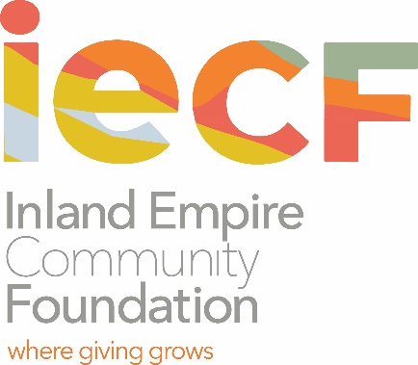
THE PGA WEST EDUCATION FUND

Scholarship Information and Criteria

The PGA WEST Education Fund established a scholarship fund with The Inland Empire Community Foundation (IECF) for the benefit of PGA WEST Country Club employees and their dependent children. The purpose of the Fund is to provide financial assistance to the PGA WEST Country Club employees and their dependent children for scholarships and other educational purposes.

The scholarships are intended to support the pursuit of any type of education that results in certification or diploma from an accredited institution such as a trade school, vocational school, community college, university or graduate school. The minimum scholarship amount is $1,000. The scholarship awards are outright grant awards. No services will be required as a consequence of receiving the award.

The scholarship is renewable, until a certificate, or a degree (two year, four year or graduate) is achieved. Renewal recipients must be enrolled, taking an acceptable course load to complete the certification or degree within a reasonable time period and have a current grade point average of 2.0 or passing for the program.
Scholarship awards are to be used for educational expenses such as tuition, books, registration/education fees, computers/laptops, and/or living expenses. Scholarship checks are made payable to the educational institution for the benefit of the scholarship recipient.

Eligibility

This scholarship is available to:
1) Employees of PGA WEST Country Club who work in the Golf Maintenance department, Golf shop, the Sports Club, the Food and Beverage areas, Housekeeping and Club Administration, and who have worked a minimum of 1,000 hours in at least each of the past two years, based on approval from the General Manager.

2) Dependent children of eligible employees.

Criteria and Procedures

Employees of The PGA WEST Country Club should:
- Have graduated, or will graduate from high school or hold a GED
- Plan to enroll as a part-time student or full-time student in an accredited trade school, vocational school, community college, or four-year university with the intention of completing a certificate program (at trade or vocational schools), or a two-year degree at a community college, or a four-year degree at a University/College
- Submit one (1) letter of recommendation from any individual other than a family member or a club member

How to Apply:
- Complete an application form
- Submit one (1) letter of recommendation
- Submit a copy of your high school diploma or GED certificate

Dependent children of eligible employees should:
- Currently be scheduled to graduate from high school in spring 2021, have previously graduated from high school or hold a GED
- Plan to enroll as a part-time student or full-time student in an accredited trade school, vocational school, community college, or four-year university with the intention of completing a certificate program (at trade or vocational schools), or a two-year degree at a community college, or a four-year degree at a University/College
- Submit one (1) letter of recommendation from any individual other than a family member or a club member
- Submit a copy of the page from the Student Aid Report (SAR) that indicates your Estimated Family Income Contribution

How to Apply – First Time Applicants:
- Complete an application form
- Submit one (1) letter of recommendation
- Submit a copy of your high school diploma, GED certificate, or most recent high school transcript
- Submit proof of dependent relationship
- Submit a copy of the page from the Student Aid Report (SAR) that indicates your Estimated Family Income Contribution
How are scholarship recipients selected?

Scholarship recipients are selected by a Scholarship Committee composed of volunteer community members and educators appointed by the Inland Empire Community Foundation. The Scholarship Committee members are not affiliated in any way with any PGA WEST club member or staff.

Submit the application packet by January 31, 2021 to:
Denisha Shackelford
Inland Empire Community Foundation
3700 Sixth Street, Suite 200
Riverside, CA 92501

For more information about the scholarship, contact: Denisha Shackelford, dshackelford@iegives.org

