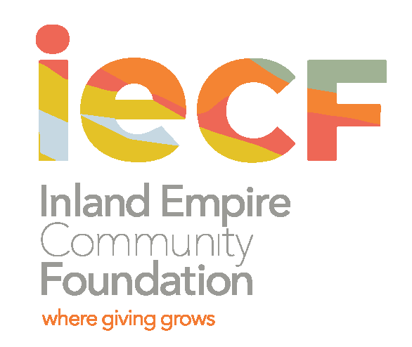
Job Posting and Description
DIRECTOR OF POLICY and GOVERNMENTAL AFFAIRS
Application Open: July 15, 2020

About the Inland Empire Community Foundation
IECF is the longest-serving community foundation in the Inland Empire, serving Riverside and San Bernardino Counties. Established in 1941, IECF works with donors of all sizes, stewards more than $100 million in assets, and provides college scholarships and grants to hundreds of students and In In nonprofit organizations. In 2018, IECF’s Board of Directors began exploring policy advocacy as a new approach for the foundation, considering new ways IECF can provide community leadership. In 2020, IECF’s Board of Directors adopted equity as a lens for its grantmaking, programs, and partnerships. Building on several years of significant growth, IECF is seeking a Director of Policy and Governmental Affairs who can formalize this work and implement new strategies in educational equity and other initiatives.
Position Summary
IECF’s Director of Policy and Governmental Affairs is a full-time position, supervised by the President and CEO. The person in this position is responsible for directing the development and implementation of the foundation's nascent public policy efforts, beginning with a two-year strategy to elevate community voices in educational reform and equitable achievement in K-12 systems in the Inland Empire. Taking a participatory approach, this position will build strategies and policy influence through deep collaboration with community-based organizations and partners while also bridging institutional relationships and cultivating partnerships with elected leaders. The person in this position will also develop strategic and operational plans to advance policies that foster equity and inclusion at multiple government levels based on continuous policy advocacy landscape analysis and strategic goals developed with diverse coalition partners, staff, and IECF’s Board of Directors.
Specific Responsibilities:
- Lead and manage IECF’s work in the area of policy and advocacy including staffing IECF’s Policy Committee;
- Plan and facilitate IECF’s strategy for educational equity including lead-managing IECF’s grantee relationships with its policy funders;
- Assist IECF’s Programs Team to make grant investments into partners and coalitions to implement educational equity policy programming;
- For educational equity specifically, develop and/or participate with diverse advocacy coalitions focused on Black, Latino, low-income and English Language Learner students;
- With partners, identify strategies and specific policy solutions for educational equity;
- Ensure strategies are executed for accomplishing short- and long-term policy advocacy goals in concert with grantees and partners;
- Undertake research. collaborate with research tables, and supervise and manage research partnerships and related contracts;
- Using an engagement plan developed with grantees and partners, engage policy leaders and local and regional elected officials to understand and inform policy issues;
- Coordinate learning events and training programs as needed;
- Lead IECF’s policy advocacy participation at state and regional tables;
- Ensure the creation of content such as landscape analyses, policy analyses, written testimony, briefs, position statements, legislative alerts, research reports, web content or electronic policy updates, or other collaterals to advance specific positions on legislative and advocacy issues;
- Communicate policy agendas through multiple communications channels including social media, earned media, presentations, partner outlets, and more;
- Organize and lead quarterly Legislative Day calls or other like events;
- Work with the President and CEO and Board Policy Committee to monitor and coordinate responses to policies, as needed;
- Assist the CEO, other staff, and Board with any presentation of communications materials, and serve as a spokesperson on policy issues as appropriate;
- Represent IECF with policy related constituents, including to the Legislature, policy and advocacy organizations, Governor’s office, education groups, and conferences.
Preferred Qualifications
- Working knowledge of research and policy related to socio-economic mobility, racial and gender equity, inclusive economic and alternative development;
- Knowledge of education, other major education systems, and related policy work—especially in California and Sacramento;
- Experience developing and executing campaigns;
- Highly motivated, creative, and strategic thinker with strong interpersonal skills;
Required Qualifications
- 5+ years of work experience in policy, advocacy, or related role, within a mission-driven entity
- Bachelor’s degree in a related field;
- A strong commitment to equity and opportunity, particularly in the area of education, and an ability to incorporate a lens of racial and gender equity for policy advocacy work;
- Experience in community-based organizations and grassroots policymaking;
- Exceptional writing, editing, and oral communication skills;
- Ability to manage projects with a focus on big goals and outcomes, remain organized, and ensure details are handled;
- Ability to use discretion, sound judgment, and maintain the strictest confidentiality when handling sensitive materials and information;
- Excellent time management;
- Technical skills in, or the ability to quickly learn, relevant software applications (Excel, MS Word, Foundant, Microsoft Teams, Powerpoint);
- A sense of humor, flexibility, and the ability to contribute to a collegial, respectful, and supportive work environment.
- Ability to work fulltime, travel by car and plane periodically, and work for consecutive hours at a computer.
How to Apply:
Please send a cover letter outlining your fit and passion for the job, along with a resume to Kim Potter, Executive Assistant, at kpotter@iegives.org. Applications will be accepted until the position is filled. When the position is closed, it will be noted on our website under “Jobs.”

