Scholarship Completion  Report #2 | 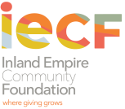 | 3700 Sixth Street, Suite 200  Riverside, CA 92501  (v) 951-684-4194 (f) 951-684-1911  www.iegives.org

MOLLY ADAMS ENDOWED SCHOLARSHIP FUND

Name of School:
Academic Year: | Total Award Amount: | Unallocated Scholarship funds (if any):
 | $
Student Information:
Student ID: | Did student complete the academic term(s)  for which he/she received a scholarship? | Grant No.  (for Office Use Only)

Completed by: | Title:

Email: | Phone: | Date:

