Scholarship Recipients  Report #1 | 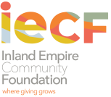 | 3700 Sixth Street, Suite 200  Riverside, CA 92501  (v) 951-684-4194 (f) 951-684-1911  www.thecommunityfoundation.net

MOLLY ADAMS ENDOWED SCHOLARSHIP FUND

Name of School: |  | Academic Year: |  |  | Total Award Amount:  $
Completed by: | Title: |  | Phone: | Email:

Student Information:
Student ID #: | Type of Disability/ Impairment | City of Permanent Residence | Enrolled part time or full time | Year in School | Scholarship Award Amount

