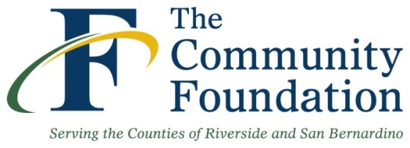 | IDYLLWILD COMMUNITY FUND  Grant Evaluation Form

Date:

Organization:

Contact Name: Title:

Phone Number: Grant Period:

Award Amount: Grant Number:

- What were the goals and objectives for the grant specified in the original grant proposal?

- Describe the project’s key outcomes and results based on your goals and objectives. Provide the number of clients served and other relevant statistics.

- What were the challenges and obstacles you encountered (if any) in attaining your goals & objectives? How did you overcome and/or address the challenges and obstacles? What were the lessons learned?

- Describe any unintended positive outcomes as a result of the efforts supported by this grant.

- Describe the overall effect this grant has had on your organization.

- Describe the partnerships developed or strengthened as a result of this grant.

- Tell us a few success stories that made an impact on your organization and/or community as a result of this grant.

- Provide a financial report on the use of your grant funds (expenditures).

- Please attach copies of publicity and other promotional materials or email them to shunke@thecommunityfoundation.net.
- All variances or time extensions must be approved by The Community Foundation’s Grant Committee. Please contact us at 951.241.7777, ext. 114 immediately if a variance or extension becomes necessary.

Please return the completed form to:
Celia Cudiamat, Executive Vice President of Grants and Programs
3700 Sixth Street, Suite 200, Riverside, CA 92501 or fax to 951.684.1911
Or email to: ccudiamat@thecommunityfoundation.net

