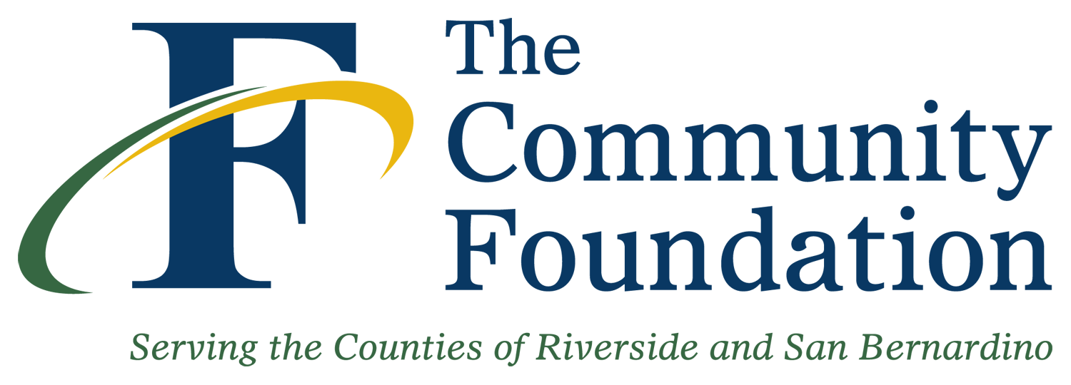 | 2013 WILLMAS FUND  Grant Evaluation Form  Due: September 15, 2014

Organization:

Contact Name: Title:

Phone Number: E-mail Address:

Grant Periods Funded and Award Amounts: # of Clients Served:
2005:
2006:
2007:
2008:
2009:
2010:
2011:
2012:
Additional relevant statistics:

Impact of Multi-Year Funding
- Describe the overall effect this grant has had on your organization over time (since the first year of funding to present). What has changed?

- Describe the overall effect this grant has had on the community over time (since the first year of funding to present). What has changed?

- Over the years, how have you leveraged this grant funding? Please describe how much additional funds you were able to raise as a result of multiple funding from the Willmas Fund.

2013 Grant Year
- What were the challenges and obstacles you encountered (if any) in attaining your goals & objectives in? How did you overcome and/or address the challenges and obstacles? What were the lessons learned?

- Describe any unintended positive outcomes as a result of the efforts supported by this grant.

- Tell us a two of the most recent success stories that made an impact on your organization and/or community as a result of this grant.

- Provide a financial (expenditure) report on the use of your current grant funds to date.

Please e-mail the completed form to: ccudiamat@thecommunityfoundation.net

