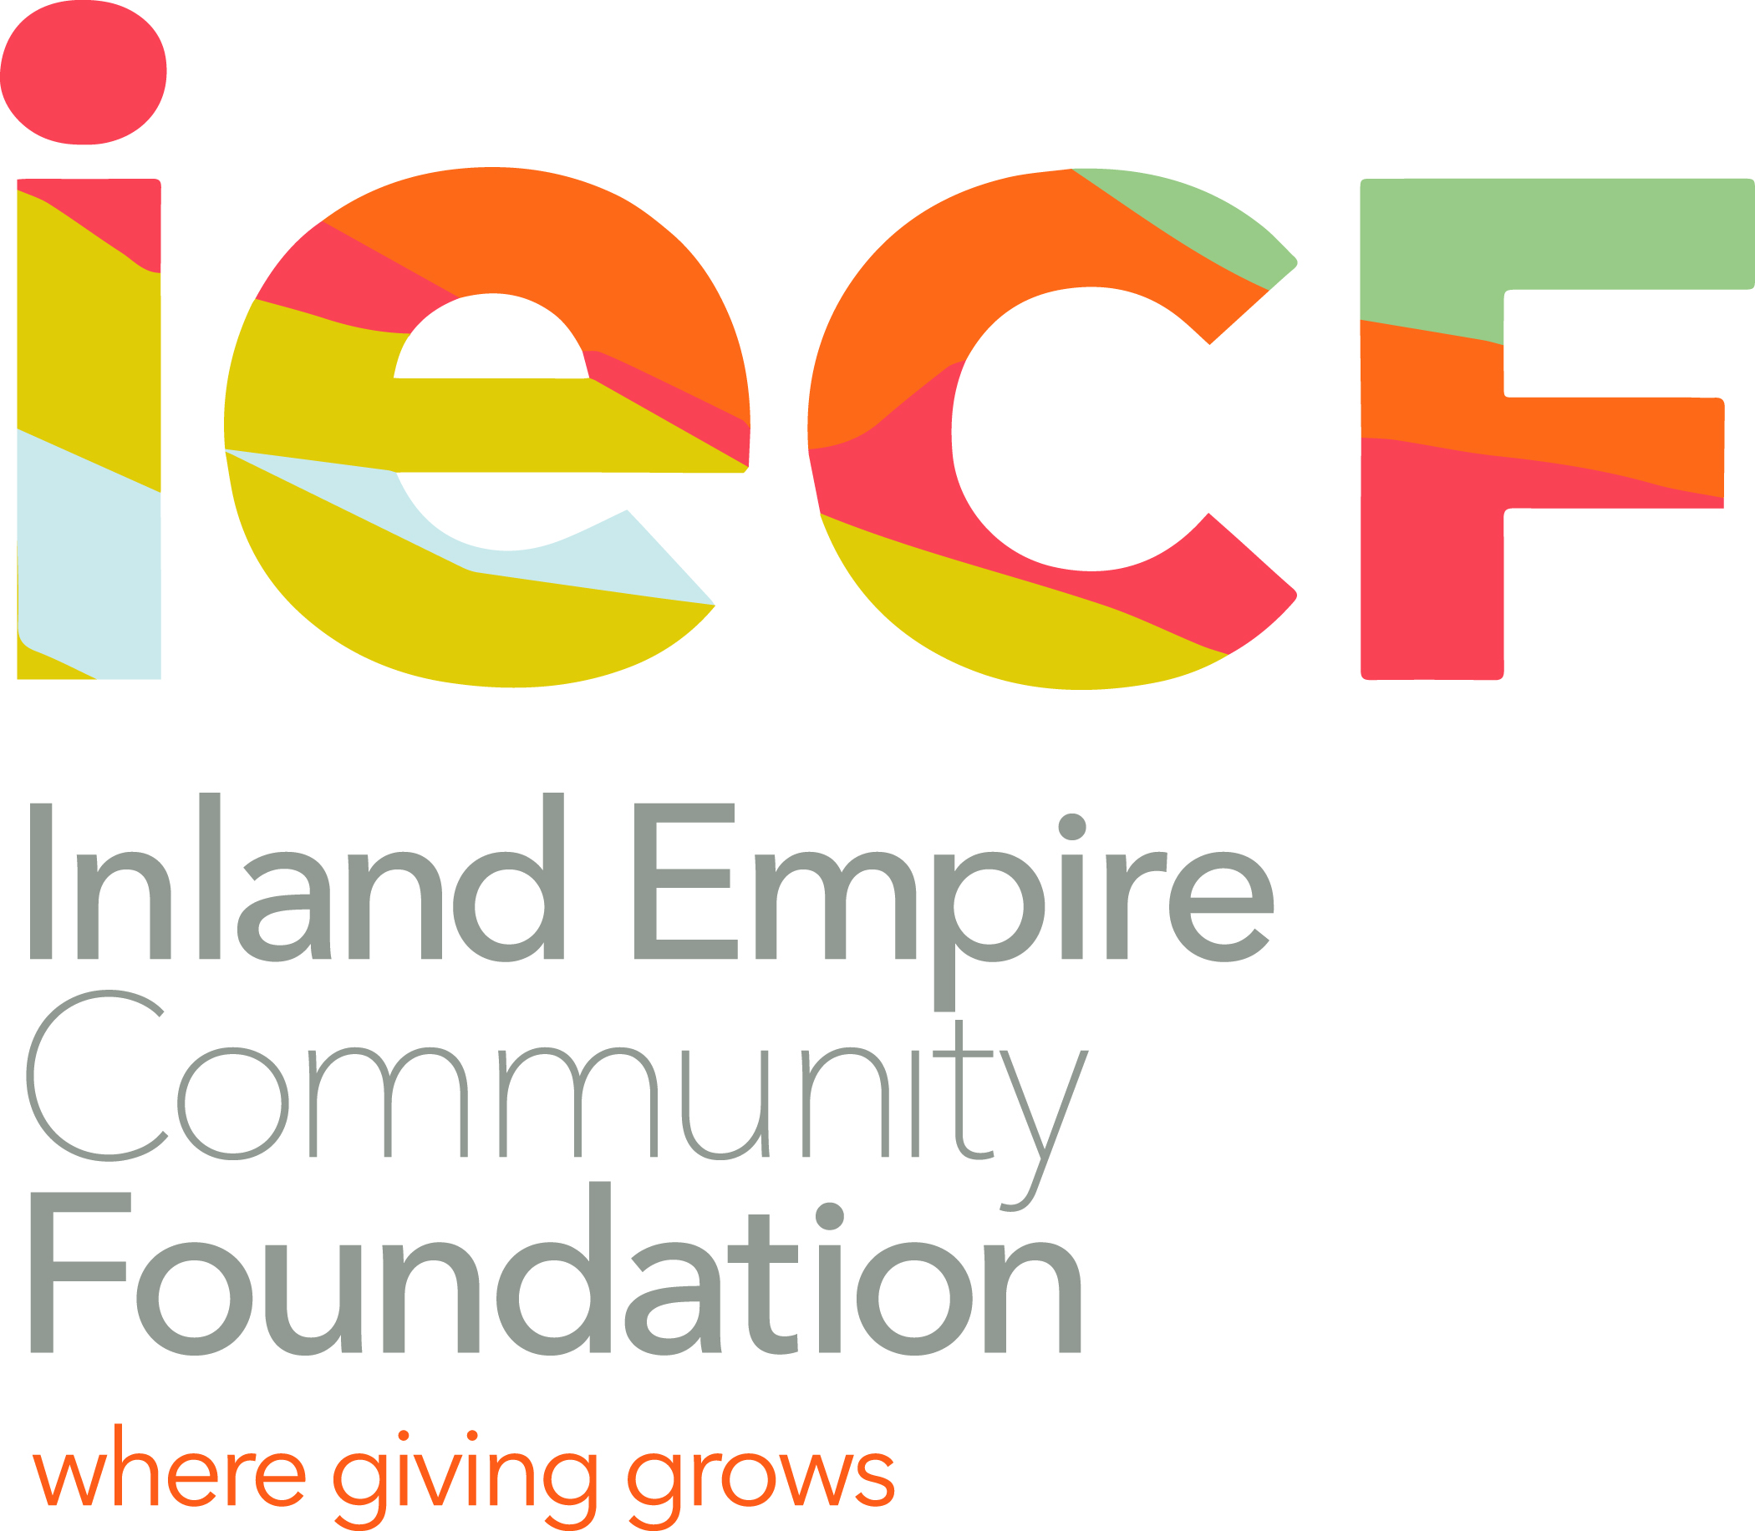
~THE MARVIN EDWARD LEGGETT JR ENDOWED FUND~
The Marvin E Leggett Jr / Linda Wilson and James Wilson Scholarship
for Alvord Unified School District ~ Riverside, CA

DEADLINE: April 3, 2020

MARVIN E LEGGETT JR spent his entire 40-year teaching career in the English Departments of two high schools--Norte Vista and La Sierra--in the Alvord Unified School District of Riverside, CA. This dedicated educator and avid book collector was known especially for his Science Fiction and Fantasy classes, as well as for his classes in the Humanities. He wanted to pass on his love of learning to Alvord students now, and also in the years to come…with these scholarships.
LINDA WILSON was a passionate advocate for both Music and the Performing Arts in Riverside and in Los Angeles, CA. JAMES WILSON, Linda’s father, was a steadfast worker in the auto industry in Riverside, CA. Both were devoted friends of Mr. Leggett and contributed to this Fund.

DESCRIPTION OF THE SCHOLARSHIPS:
- This Scholarship provides a TOTAL of $4000 @ $1000 per year over FOUR years -- for the recipient from any of the three high schools of Alvord Unified School District in Riverside, CA.
- This Scholarship provides $1000 EACH YEAR for FOUR years, if the recipient 1) remains a full time student at a community college and/or a four-year college or university, and 2) maintains a GPA of 3.0. This is not automatic: you MUST contact Inland Empire Community Foundation with your GPA and brief summary of the just-past year of college, after each & every year… for a potential total of $4000.
- This scholarship shall be used for educational expenses, such as tuition, fees, books, school-related supplies i.e. technology, musical instrument or housing--via the college or university you are attending.

SCHOLARSHIP CRITERIA: The applicant shall…
- Have a minimum high school GPA of 3.25
- Be a Senior at Norte Vista or La Sierra or Hillcrest High School in AUSD of Riverside, CA
- Demonstrate financial need (include FAFSA amount to be awarded and why)
- *Preference will be given to those considering careers in (1) education (teaching), (2) in the creative arts such as writing, speaking, dancing, performing, music, photography, film, drawing/painting, pottery etc. (3) community service, (4) environmental protection, (5) peace studies.
- *If you are undecided and searching for your major or direction in life, you may still apply.

The APPLICATION PACKET should include:
- Completed application
- Two letters of recommendation (from teachers, counselors, or unrelated community members)
- Transcripts (including GPA and SAT or ACT test scores)
- Essay (see application form for specific instructions)

SUBMIT the application packet ON OR BEFORE THE DEADLINE APRIL 3, 2020, 5PM, to:
Denisha Shackelford @ Inland Empire Community Foundation
3700 Sixth Street, Suite 200 -- Riverside, CA 92501
For more information/questions, contact Denisha Shackelford
951-241-7777 or email: dshackelford@iegives.org
APPLICATION FORM
- The Marvin E. Leggett Jr / Linda Wilson and James Wilson Scholarship

DEADLINE: April 3, 2020 PLEASE PRINT CLEARLY OR TYPE:

I. APPLICANT INFORMATION:

Name: _________________________________________________________________________________________________________
Last, First Middle

Address: ___________________________________________________ City & ZIP: ______________________________________

Cell Phone Number: (_____)___________________________________________

Email: ____________________________________________________________________________ Gender: ________________

II. FAMILY INFORMATION:

Names of Parent(s) or Guardian(s):

______________________________________________________/____________________________________________________________

Address(es):_________________________________________________/___________________________________________________

Occupation(s): __________________________________Phone Number(s): ___________________/______________________

Number/ages of Siblings: ______________________________________________________________________________________

III. TRANSCRIPT INFORMATION: (Attach your transcript): Your overall High School GPA ___________

Your Test Scores: SAT -- Reading ___________Math ___________ Writing ____________ or ACT _______________

IV. SCHOOL ACTIVITES / COMMUNITY ACTIVITES / SERVICE (such as volunteer work or religious involvement):

ORGANIZATION/ACTIVITY | LOCATION | DATES | TIME SPENT IN  PARTICIPATION | OFFICES HELD | AWARDS  HONORS

Which Alvord high school do you currently attend? ______________________________________________

What middle school did you attend? ______________________________ City & State: __________________________
Page 2 LEGGETT / WILSON SCHOLARSHIP APPLICATION FORM

FINANCIAL NEED: HOW DO YOU EXPECT TO MEET YOUR EDUCATIONAL EXPENSES?
Please describe any financial need, unusual family and/or personal circumstances. For example, if you are not living with your parents, provide any information about your living arrangements, your financial or emotional needs and any additional information which you feel may be relevant. Use an additional sheet if necessary, or you may include this in your ESSAY (see below).
( Include YOUR FAFSA SCORE )________________________________________________________________________________ ________________________________________________________________________________________________________________________________________________________________________________________________________________________________________

LIST CURRENT/PAST EMPLOYMENT: (Do you plan to work while you are attending college? ______)
Job Description | Employer | Hours | Dates | Rate of Pay

COMMUNITY COLLEGES, 4yr COLLEGES & UNIVERSITIES APPLIED TO: (Use * if accepted )

1.________________________________________________________________________________________(accepted? ________)
2.________________________________________________________________________________________(accepted?_________)
3.________________________________________________________________________________________(accepted?_________)
INTENDED POTENTIAL MAJOR AREA OF STUDY, if you know : _______________________________________

ESSAY: Write an original ESSAY of paragraphs (300+ words) explaining: 1 + (choose 2a, b, c, or d) + 3
1. Who you are, what you care about and enjoy, plus any goals you may have, like why you
want to become an educated person these days.
2a. What influences and motivates your wanting to become a teacher--an educator, and in what subject(s) or grade or level, if you know?
OR 2b. What do you love about your art (writing, speaking, performing, dancing, music, drawing/
painting, photography, etc)? How did you discover this creative interest, talent, skill, desire?
OR 2c. What motivates you towards community service, or environmental protection, or peace work?
OR 2d. If you are undecided about your intended major area of study, write instead: what are your interests and what makes you happy, fulfilled, centered, excited, concerned?
3. What is your financial need? Why do you want or deserve this scholarship? What else would you like us to know about you or your situation?

LETTERS OF RECOMMENDATION:
Please attach two (2) letters of recommendation from people who are knowledgeable about any of the following: your financial need, academic capabilities, skills, and goals; your school, community, civic, religious activities and/or volunteer service; your character; your interests, life goals and values. (recommending writers may be teachers, counselors, unrelated community members)

APPLICANT CERTIFICATION:
I certify that the information provided in this application is complete and accurate to the best of my knowledge. I understand that falsification of information may result in termination of any scholarship granted. Good luck.

Printed Name: ______________________________________________________________________________________

Signature: ____________________________________________________ Date: _________________________

