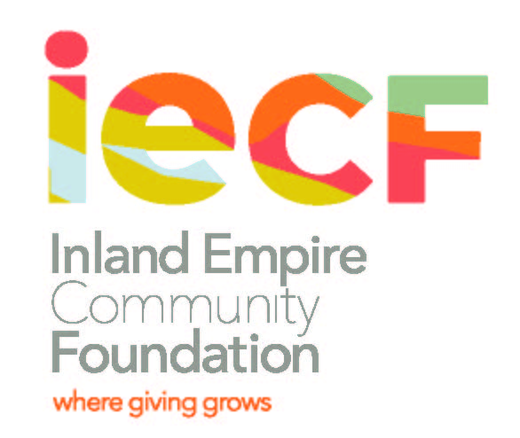

Desert Outreach Foundation
Scholarship Information and Criteria

The Desert Outreach Foundation, founded in 1999, is dedicated to improving the Coachella Valley community by assisting and supporting young people of merit, in need with their career & academic endeavors. In 2019, the Desert Outreach Foundation Scholarship Fund will award a minimum of five, one-year scholarships to students who live in the Coachella Valley. Scholarship award amounts may range between $1,000 and $2,000 depending on the number of scholarships awarded.

Who is eligible to receive the scholarship?
The Fund provides financial assistance in the form of scholarships to students residing in the Coachella Valley who are seeking an undergraduate/graduate degree either within or outside of the Valley. Scholarships are to be used for education-related expenses such as tuition, educational equipment and supplies.

Scholarship Criteria and Procedures
Applicants will be selected based on the following:
- Financial need | - Essay
- Scholastic achievement | - Career or educational goal
- Community service | - Letter of recommendation
- Full time student | - Interview (if needed)
How are scholarship recipients selected?
Scholarship recipients are selected by a scholarship committee composed of educators and community members. Applications are reviewed competitively. A rating system is used which includes: Financial Need, Scholastic Achievement, Community Service, Essay and Letters of Recommendation. Financial Need is given the highest priority in the rating process.

How to apply for the scholarship and submission instructions:
Eligible students must complete: 1) An application form; 2) a letter of recommendation (from counselor and/or others not related to the applicant) that verify community service; 3) an essay; 4) transcript (unofficial is acceptable; 5) Copy of FAFSA – EFC (Estimated Family Contribution) page. Final award recipients must provide evidence of enrollment in the academic institution to which funds will be paid on behalf of the recipient.

Submit the application packet to:
Denisha Shackelford
Inland Empire Community Foundation
3700 Sixth Street, Suite 200, Riverside, CA 92501

Desert Outreach Foundation
Application Deadline: April 2, 2020

PLEASE PRINT OR TYPE:

- APPLICANT INFORMATION:
Name:
Last First Middle
Address:
Number Street Apt. City State Zip Code

Home Phone Number: ( )______________ Cell Phone: ( )

E-mail Address:

Cell Phone #: Birthdate:__________________ Male __ Female ___
How many years have you lived in the Coachella Valley?

Have you already, or will you graduate from a California High School? Yes No

- TRANSCRIPT INFORMATION: A transcript must be attached to this application
An unofficial High School or College transcript is acceptable for this application. If selected for a scholarship, an official transcript will be required.

High School Applicants

Name of High School:

Cumulative GPA: ______________________

SAT Scores: Total _________ Verbal__________ Math__________ Writing________

College Applicants

Name of College:

Year in College: Cumulative GPA:_____________________

- MAJOR SCHOOL ACTIVITIES
List all school activities in which you have participated during the past 4 years (e.g. Student government, Campus Clubs, Performing Arts, Sports, etc.). Attach copies of Scholastic Honors, Awards received. Use additional sheet if necessary.
Activity | Years of Participation | Special Awards, Honors | Activity | Years of Participation | Special Awards, Honors

IV. COMMUNITY ACTIVITIES/VOLUNTEER WORK
List all community activities/volunteer work in which you have participated in without pay during the past 4 years. Use additional sheet if necessary.
Activity | Years of Participation | Special Awards, Honors | Activity | Years of Participation | Special Awards, Honors

V. WORK EXPERIENCE
Employer | Dates Employed | Job Description | Hours Worked per Week | Hourly Rate of Pay

VI. FINANCIAL NEED
Financial need is a major consideration for this scholarship.

- Did you apply for Financial Aid (Free Application for Federal Student Aid- FAFSA)?
Yes_____ Please provide a copy of your FAFSA application OR a copy of the Student Aid Report (SAR) that you received from the U.S. Department of Education.

No_____ Please provide a statement that documents your financial situation. For dependent students, provide information on your parents’ financial situation.

NOTE: If you send documents showing social security numbers, please BLACK OUT the numbers before sending them to us. Documents showing social security numbers cannot be accepted and your application may be considered as incomplete.

VII. ESSAY:
Write an essay (maximum 500 words) on why this scholarship is important to you; the person you are now and the person you wish to be in the future; your educational and vocational goals; and, what giving back to the community means to you.

VIII. LETTER OF RECOMMENDATION:
Please attach one (1) letter of recommendation from individuals other than family members.

IX. APPLICANT CERTIFICATION
I certify that the information provided in this application and attachments is complete and accurate to the best of my knowledge. I understand that the contents of this application will be shared with appropriate Review/ Approval Committees. If I am awarded a scholarship, it will be used solely to support educational purposes and that information about me may be released for publicity purposes.

Printed Name:________________________________________________________________________

Signature: _________________________________________________ _

Date:_____________________

Application Package Checklist

 Scholarship Application Form
 Transcript
 Essay (maximum 500 words). Include name on top of essay page
 One (1) letter of recommendation
 Copy of the Student Aid Report (SAR) that you received from the U.S. Department of Education (Estimated Family Contribution page only).

