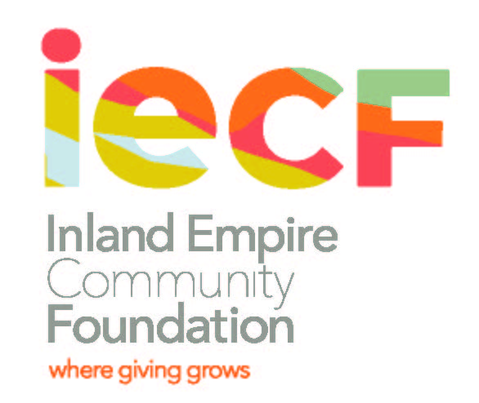

The Rosemarie Cionni - Mary Pastore Educational Trust
Scholarship Fund

The Rosemarie Cionni – Mary Pastore Educational Trust Scholarship Fund provides college financial assistance to a female, outstanding graduating senior from Elsinore High School who is pursuing a college education at an accredited community college, state college, Catholic college or university.
Recipients receive a scholarship award to an accredited public or private institution of higher learning. The scholarship awards are outright grant awards. No services will be required as a consequence of receiving the award. Scholarship awards are for tuition, books, education fees, and/or living expenses. The scholarship award is $3,000. The recipient may continue to receive funds so long as she maintains a “B” average and carries an academic load of a minimum of 12 units per quarter or semester.

Scholarship criteria:
  - Minimum 2.75 G.P.A.
  - Female, high school graduating senior, planning to attend a college or university full time
  - Exhibit community and school involvement.
  - Demonstrate financial need.

The application packet should include:
- Completed application form
- 2 letters of recommendation
- Transcript
- Essay
- Copy of FAFSA – EFC (Estimated Family Contribution) page
- Copies of awards and honor certificates
- A statement from the applicant’s parents regarding financial need

Submit the application packet to:
Jeanie Corral
The Rosemarie Cionni-Mary Pastore Educational Trust Scholarship
18014 Heidi Lisa Lane
Lake Elsinore, CA 92532

For more information, contact Denisha Shackelford at dshackelford@iegives.org

The Rosemarie Cionni - Mary Pastore Educational Trust
Scholarship Fund
Application Due: March 20, 2020

PLEASE PRINT OR TYPE:

- APPLICANT INFORMATION:
Name:___________________________________________________________________________
Last First Middle
Address:_________________________________________________________________________
Number Street Apt. City State Zip Code

Home Phone Number: ( )_______________ E-mail Address: _________________________

Birthdate:______________________________

- FAMILY INFORMATION:
Name of Parent or Guardian:_______________________________________________________

Address:_________________________________________________________________________
Number Street City State Zip Code
Occupation: ____________________________Telephone Number: ( ) __________________

- TRANSCRIPT INFORMATION: A transcript must be attached to this application
GPA: (weighted) ______
SAT Scores: Total ______ Critical Reading_____ Math_____ Writing _______

- MAJOR SCHOOL ACTIVITIES
List all school activities in which you have participated during the past 4 years (e.g. Student government, Clubs (legitimate ones recognized on campus), Performing Arts, Sports, etc.)

Activity | Years of Participation | Special Awards, Honors | Activity | Years of Participation | Special Awards, Honors

V. COMMUNITY ACTIVITIES
List all community activities in which you have participated in without pay during the past 4 years (e.g. Scouts, Church involvement, Volunteer work, etc.)

Activity | Years of Participation | Special Awards, Recognition | Activity | Years of Participation | Special Awards, Recognition

VI. WORK EXPERIENCE
Employer | Dates Employed | Job Description | Hrs Worked per Week | Hourly Rate of Pay

VII. COLLEGE/UNIVERSITY APPLIED TO AND MAJOR
The accredited colleges/universities I have applied to and Major:
1.___________________________________________________________________________________
2. _________________________________________________________________________________
3.___________________________________________________________________________________

VIII. ESSAY:
Write an essay (max. 300 words) on what you hope to achieve with a college degree, the major you are pursuing and why, and the need for this scholarship. Include your educational and career goals.

IX. LETTERS OF RECOMMENDATION:
Please attach two (2) letters of recommendation from individuals who are knowledgeable about your academic capabilities, skills, and talents.

X. APPLICANT CERTIFICATION
I certify that the information provided in this application is complete and accurate to the best of my knowledge. I understand that falsification of information may result in termination of any scholarship granted. I understand that the contents of this application will be shared with appropriate Review/ Approval Committees. If I am awarded a scholarship, information about me may be released for publicity purposes.

Printed Name: ___________________________________________________________________

Signature: ___________________________________________________ Date_____________

Submit the application packet to:
Jeanie Corral
The Rosemarie Cionni-Mary Pastore Educational Trust Scholarship
18014 Heidi Lisa Lane, Lake Elsinore, CA 92532

