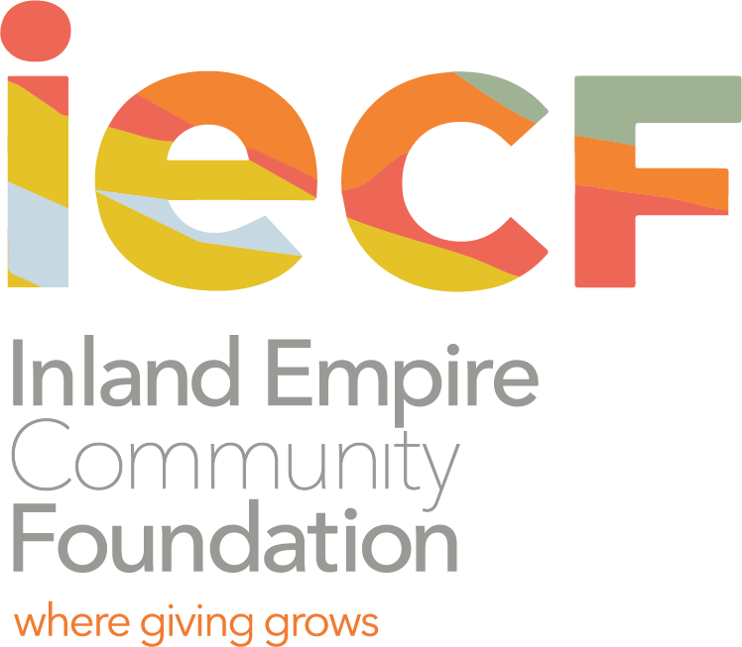

The Castro/Falk Scholarship Fund of the Coachella Valley
Scholarship Information and Criteria

Sun Gold, Inc. represented by Efren Castro and Elynor Rudnick Falk, was active in agribusiness in the Coachella Valley, contributing substantially to the economy of the area.

The Castro/Falk Scholarship Fund of the Coachella Valley is established as an endowed scholarship by David Falk and Lisa Castro to honor the memory of Efren Castro and Elynor Rudnick Falk in perpetuity.

Who is eligible to receive the scholarship?
The Fund provides financial assistance in the form of scholarships to students who are U.S. citizens, and residents, or former residents, of Coachella Valley who demonstrate motivation, perseverance and a sincere desire to gain an education, be it high school, vocational school, community college, undergraduate or graduate college or university. There shall be no discrimination in the selection of students for aid based upon gender, race, religion, country of origin, or parentage.

Scholarships are provided to students who demonstrate financial need, and may be used for education-related expenses such as tuition, equipment, supplies, food, lodging and clothing. Funding may be provided for study abroad if it is part of a school’s formal course of study. Funding shall not be provided for extracurricular activities not part of an educational program, such as vacations or participation in private social, religious or political activities.

Students receiving financial assistance from the Fund are required to maintain a minimum academic standing of “C” or its equivalent. Consistent failure to maintain qualifying academic status may disqualify students from receiving further financial assistance. Further, any criminal or otherwise illegal activity, lapse in appropriate conduct (e.g. cheating, plagiarism, illegal use of drugs or alcohol, expulsion from school), may disqualify students from receiving further financial assistance.

How to apply for the scholarship?
Eligible students must complete an application form. The application packet includes: Completed application form; two letters of recommendation (from an academic counselor or others not related to the applicant); and transcript. Final award recipients must provide evidence of enrollment in the academic institution to which funds will be paid on his or her behalf.

How are scholarship recipients selected?
Scholarship recipients are selected by a scholarship committee and approved by the Inland Empire Community Foundation Board of Directors. Applications are reviewed competitively, and may be supported by a personal interview with each finalist.

Submit the application packet to:
Denisha Shackelford
Inland Empire Community Foundation
3700 Sixth Street, Suite 200, Riverside, CA 92501

The Castro/Falk Scholarship Fund of the Coachella Valley
Scholarship Application
Application Deadline: April 2, 2020

PLEASE PRINT OR TYPE:

- APPLICANT INFORMATION:
Name:
Last First Middle
Address:
Number Street Apt. City State Zip Code

Home Phone Number: ( )______________ Evening Phone: ( )

E-mail Address:

Cell Phone #: Birthdate:__________________ Male __ Female ___

- TRANSCRIPT INFORMATION: A transcript must be attached to this application
An unofficial High School or College transcript is acceptable for this application.

High School Applicants

Name of High School:

Cumulative GPA: ______________________

SAT Scores: Total _________ Verbal__________ Math__________ Writing________

College Applicants

Name of College:

Year in College: Cumulative GPA:___________________

- MAJOR SCHOOL ACTIVITIES
List all school activities in which you have participated during the past four (4) years (e.g. Student government, Campus Clubs, Performing Arts, Sports, etc.). Attach copies of Scholastic Honors, Awards received. Use additional sheet if necessary.
Activity | Years of Participation | Special Awards, Honors | Activity | Years of Participation | Special Awards, Honors

IV. COMMUNITY ACTIVITIES/VOLUNTEER WORK
List all community activities/volunteer work in which you have participated in without pay during the past four (4) years. Use additional sheet if necessary.
Activity | Years of Participation | Special Awards, Honors | Activity | Years of Participation | Special Awards, Honors

V. WORK EXPERIENCE
Employer | Dates Employed | Job Description | Hours Worked per Week | Hourly Rate of Pay

VI. FINANCIAL INFORMATION
Have you applied for and/or received other scholarships? Yes _____ No ____
Name of Scholarship Amount Received

Did you apply for Financial Aid (FAFSA)? Yes_____ No_____
If so, what is your EFC (Estimated Family Contribution) as determined by the Student Aid Report (SAR) ? _____ Please provide a copy of the page from the SAR that indicates your EFC

How do you expect to meet your educational expenses? Please explain.

VII. HIGH SCHOOL APPLICANTS: COLLEGE, UNIVERSITY, VOCATIONAL
The top three, accredited colleges, universities, vocational schools, I have applied to for the Fall 2018 Term are:
1.
2.
3.

Do you intend to be employed while attending college? Yes _____ No _____

VIII. ESSAY:
Write an essay (maximum 500 words) on why this scholarship is important to you; the person you are now and the person you wish to be in the future; your educational and vocational goals; and, what giving back to the community means to you.

IX. LETTER OF RECOMMENDATION:
Please attach one (1) letter of recommendation from an academic counselor or others not related to the applicant.

X. APPLICANT CERTIFICATION
I certify that the information provided in this application and attachments is complete and accurate to the best of my knowledge. I understand that the contents of this application will be shared with appropriate Review/ Approval Committees. If I am awarded a scholarship, it will be used solely to support educational purposes and that information about me may be released for publicity purposes.

Printed Name:____________________________________________________________________

Signature: _________________________________________________

Date:_____________________

Application Package Checklist
 Scholarship Application Form
 Transcript
 Essay (maximum 500 words). Include name on top of essay page
 One letter of recommendation
 Student Aid Report (SAR) that you received from the U.S. Department of Education (Estimated Family Contribution-page only)

