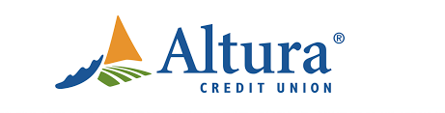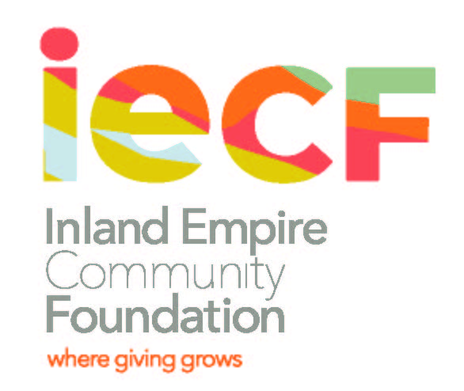
January 20, 2020

Dear High School Senior:

Each year, The Altura Credit Union Foundation awards monetary scholarships to Riverside County High School seniors pursuing a college education.

In addition, scholarships are available from four separate endowments, each of which has a different set of criteria. Students applying for any of the Altura Credit Union Foundation scholarships will need to fill out only one application. Students should highlight their academic achievement, community service/extracurricular activities, financial need and personal character/leadership qualities.

The Community Foundation serving the Counties of Riverside and San Bernardino administers The Altura Credit Union Foundation’s Scholarship Funds.
Scholarship Funds and Criteria

Altura Credit Union Foundation General Scholarship
• Enrollment in an accredited post-secondary institution
• A graduate of a high school in Riverside County

Altura Member Scholarship
This scholarship is designed for graduating high school seniors who are current Members of Altura Credit Union or an immediate family member of a current Member.

The Bonnie Gail Polis Educational Endowment
• Enrollment in an accredited post-secondary institution
• Expressed intention of pursuing a career in public education (i.e. Teacher, Counselor, Administrator, etc.)
• A graduate of a high school in the Riverside Unified School District (Arlington, King, North, Poly, Ramona)

The Terry Ferrone Memorial Scholarship
• Enrollment in an accredited post-secondary institution
• A graduate of John W. North or Poly High Schools in Riverside, CA

Dr. Linda Wisher Educational Endowment
This Endowment is in memory of a former Board of Director, Dr. Linda Wisher, for a scholarship to females pursuing a career in education for graduating seniors. Endowments will be at the direction of the Altura Credit Union Board of Directors.

Kimberly Jean Flores Memorial Scholarship
• Enrollment in an accredited post-secondary institution • Academic achievement
• Financial Need | • Community service / extracurricular activities
• Personal character / leadership qualities | • Enrollment in an accredited post-secondary institution
• A graduate of Canyon Springs High School in Moreno Valley

How to Apply:
1. TYPE all information in black ink.
2. Download the application form at: www.iegives.org .
Go to the Scholarships menu; scroll down to “Scholarship Applications” and click on the Altura application.
You can also download the application form at the Altura website.
3. Answer all the questions thoroughly. TYPE all answers. Attach all required documents.
4. Use a PAPER CLIP for the application form and attachments. DO NOT STAPLE anything.

PLEASE DO NOT STAPLE
DO NOT COPY DOUBLESIDED
DO NOT SUBMIT/DROP OFF APPLICATION TO THE CREDIT UNION

5. Submit Completed Application by 5:00pm, on or before March 16, 2020, to:
Denisha Shackelford
Inland Empire Community Foundation
3700 Sixth Street, Suite 200, Riverside, CA 92501
For more information, contact Denisha Shackelford at dshackelford@iegives.org
For office use only
Last_______________
First_______________
GPA_______________
SAT_______________
ACT_______________
AVID_______________
UCR_______________

Altura Credit Union Foundation
2020 Scholarship Application
DEADLINE: MARCH 16, 2020
IMPORTANT
• Type all information in black ink.
• Use paperclips for fastening attachments. No staples.
• Submit one application only and note all scholarships you are applying for. Be sure to review all scholarship requirements and check all that apply below. All scholarships are a one-time award for a 2020 high school graduating senior.

*Are you or someone in your family a member of Altura Credit Union? ____ Yes or ____ No

Which scholarship are you applying for? (Check all that you are qualified for.)
Altura CU Foundation General Scholarship
• Academic achievement – 3.25 GPA
• Financial Need | • Community service / Leadership qualities
• A graduate of any high school in Riverside County | • Enrollment in an accredited post-secondary institution
Altura Member Scholarship
Graduating high school seniors who are current Members of Altura Credit Union or an immediate family member of a current Member.
• Academic achievement • Financial Need
• Community service / Leadership qualities | • Enrollment in an accredited post-secondary institution

Bonnie Gail Polis Educational Endowment
• Expressed intention of pursuing a career in public education (i.e. Teacher, Counselor, School Administrator)
• Academic achievement • Financial Need
• Community service / Leadership qualities | • Enrollment in an accredited post-secondary institution
• A graduate of a high school in the Riverside Unified School District (Arlington, King, North, Poly, Ramona)

Kimberly Jean Flores Memorial Scholarship
• Academic achievement
• Financial Need | • Community service / extracurricular activities
• Personal character / leadership qualities | • Enrollment in an accredited post-secondary institution
• A graduate of Canyon Springs High School in Moreno Valley, CA

Terry Ferrone Memorial Scholarship
• Academic achievement • Financial Need
• Community service / Leadership qualities | • Enrollment in an accredited post-secondary institution
• A graduate of John W. North or Poly High School in Riverside, CA

Dr. Linda Wisher Educational Endowment
• Graduating female, high school senior pursuing a career in education
• Financial Need | • Leadership qualities
• Community service | • Enrollment in an accredited post-secondary institution

Altura Credit Union Foundation
2020 Scholarship Application
DEADLINE: MARCH 16, 2020

1. Applicant Information
Applicant’s Name (last)
(first)
Address (residence)
City, State, Zip
Home Phone _________________________________ Cell Phone
E-mail address
School School District
Age ____ Male _______ Female _______

2. Academic Information
Name of High School and City
Weighted GPA _________ (Attach a transcript to this application - required).

Are you enrolled in any special courses (AP, Honors, IB, etc.)? Yes _____ No _____

Are you enrolled in AVID? Yes ___ No ___
Name of AVID Teacher

3. Family Information
With whom are you living?
Name Relationship
Occupation(s) _________________________________________________________
Employer(s) __________________________________________________________
Number of children living in your household? ______

Please provide the following information about your siblings:
Age | Sex | Occupation or School | Living at Home (Y or N)

If you are not residing with your parents, use this space to provide any relevant information about your living arrangements, financial and/or emotional support needs, etc., which you feel may be of use in the evaluation of your application.

Altura Credit Union Foundation
2020 Scholarship Application
DEADLINE: MARCH 16, 2020

4. Honors, Awards, and Activities
Please provide us with a list of your school-related extracurricular activities, including school clubs, sports, and any other activities. Provide approximate dates of participation, and any offices or chairmanships you may have held.
Year 1:
Year 2:
Year 3:
Year 4:

Please list any community activities you have been involved in during your high school years (e.g. scouting, church, election campaigns, volunteer service, etc.) and also list and describe any awards, commendations/special recognitions you have received.

5. Financial Information
Have you applied for and/or received other scholarships? Yes _____ No ____
Name of Scholarship Amount Received

Did you apply for Financial Aid (FAFSA)? Yes_____ No_____
If so, what is your EFC (Estimated Family Contribution) as determined by FAFSA? _____
(Please provide a copy of the page from FAFSA that indicates your EFC)

How do you expect to meet your educational expenses? Please explain.

6. College/University
The top three, accredited colleges/universities I have applied to for the Fall 2020 Term are:
1.
2.
3.

7. Student Employment Information
Present employer (if any)
Name
Address
Hours per week: _______ Earnings per week: _______
Nature of work:

Do you intend to be employed while attending college? Yes _____ No _____

Altura Credit Union Foundation
2020 Scholarship Application
DEADLINE: MARCH 16, 2020

8. Essay
Write an essay (max. 300 words) on what you hope to achieve with a college degree, the major you are pursuing and why, and the need for this scholarship. Include your educational and career goals.
(Attach the essay to this application with a paper clip). Please be sure to put your name at the top of your essay.

9. Attachments/Mailing (use paper clips please)
Please include:
1) Two (2) letters of recommendation from individuals other than your parent or Guardian.
2) Your high school transcripts.
3) Essay (as described in #7).
4) If your SAT or ACT test scores are not included on your transcripts please include a copy of test scores.
5) FAFSA - EFC (Estimated Financial Contribution) verification.

Mail your completed application to: (Do not deliver to a credit union branch)

Denisha Shackelford
Inland Empire Community Foundation
3700 Sixth Street, Suite 200
Riverside, CA 92501

Deadline: Must be received in the TCF office on or before 5:00 p.m. on March 16, 2020.

***************************************************************************************************
Application Package Checklist

 Scholarship Application Form
 Transcript
 Essay (maximum 300 words) Include name on top of essay page
 Two (2) letters of recommendation
 Copy of SAT or ACT scores if not included on transcript
 Copy of SAR (Student Aid Report) – EFC (Estimated Family Contribution) page

