

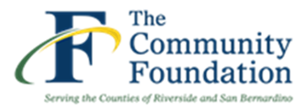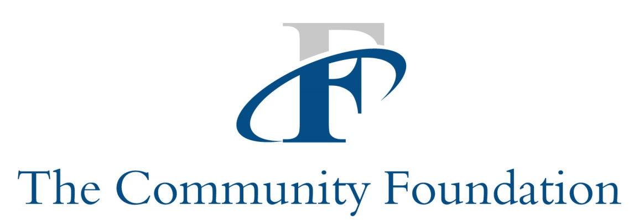



**2019 SMALL GRANT PROGRAM**

**Guidelines and Instructions**

**Deadline: April 1, 2019**

***Environmental Education Collaborative***

The mission of the Environmental Education Collaborative (EEC) is to provide funding, program, and policy resources to support environmental education programs in Riverside and San Bernardino Counties.

***Request for Proposals***

The Community Foundation (TCF) serves as the administrator for the EEC Small Grant Program. Funds for the EEC Small Grant Program are provided by Southern California Edison International. Proposals are being accepted for activities, programs and projects per below.

***Program Interest Areas***

* Collaborative projects or programs that connect informal (non-profit) with formal (K-12) providers
* Field trips
* Science projects
* Class/community gardens
* Project-based staff support
* Programs or projects that demonstrate STEM, NGSS or EEI alignment

***Eligibility***

* Non-profit outdoor/environmental/science education providers that are public benefit organizations with evidence of tax-exempt status under Section 501(c)(3) of the Internal Revenue Code and not classified as a private foundation.
* Public, private or charter school K-12 classroom teachers or schools
* Environmental education support groups/projects affiliated with non-profit or school programs per above

***Grant Amount*:**  Grants awarded will be $1,000 - $2,000

***Grant Period:*** June 1, 2019 to February 28, 2020

***Limitations***

These types of expenses are not eligible for funding:

|  |
| --- |
| * Travel expenses |
| * Conference fees |
| * Political or religious initiatives |

***Application Deadline:* April 1, 2019**

***Application Review***

Grants are awarded on a competitive basis. Applications will be screened for eligibility and completeness by The Community Foundation (TCF) staff. A Grant Review Committee of The Community Foundation will evaluate the proposals and make grant recommendations to The Community Foundation Board of Directors for final approval.

.

***Notification of Results***

**All applicants will be notified of the results, in writing, by May 30, 2019.** Recipients will be invited to present their awarded project or program at EEC’s 2019 annual symposium held in February.

***Submission of the Application Packet***

* Download the application form at [www.thecommunityfoundation.net/grants](http://www.thecommunityfoundation.net/grants) or [www.enviroedcollaborative.com](http://www.enviroedcollaborative.com)
* Completed Grant Application Form (Two pages application form and Budget Page).
* For nonprofit entities, submit a copy of your current 501(c) (3) determination letter from the IRS.
* Email your application packet to [ccudiamat@thecommunityfoundation.net](mailto:ccudiamat@thecommunityfoundation.net)
* Late applications and incomplete applications will be disqualified

***Questions***

* For questions, email ccudiamat@thecommunityfoundation.net

Limited funding is available to support the continuance and development of new programs or projects focused on ***environmental and science education*** in San Bernardino and Riverside Counties.