23 May 2014

Karen Lampert
The Community Foundation
3700 Sixth Street, Suite 200
Riverside, CA 92501

2014 Spring Update

Dear Karen,
I hope this letter finds you well. I am between trips, and want to give you an update on the work we are doing to improve nutrition for the families served by the food bank network.

SeaShare continues to work with, and for, the member companies of the National Fisheries Institute. Last year’s NFI class of Future Leaders --- 35 seafood professionals from all over the country --- generated over 100,000 pounds of donated seafood, plus $20,000, to aid our hunger-relief efforts. We also spent an afternoon in January volunteering at the Feeding South Florida Food Bank. I appreciate all their help, and I really enjoy rolling up my sleeves with them.

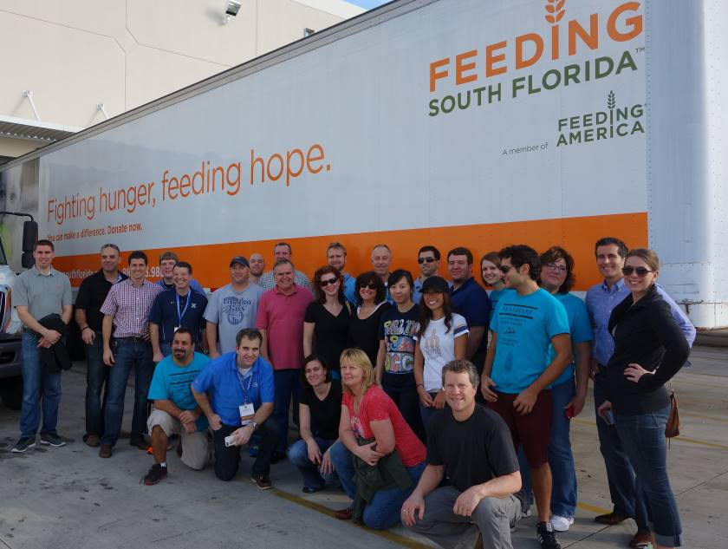

SeaShare board member Michael Lieberman is co-chair of NFI’s Future Leaders committee. Michael confirms that this year’s class project will again support hunger-relief. Seafood is a fantastic and much-needed source of lean protein for the food banks we serve.
SeaShare continues to recruit new partners to help us reach more communities. High Liner Foods, based in Portsmouth NH, has increased their donations substantially; donating seafood + processing + financial support. SeaShare board president Glenn Reed presented our 2014 New Donor of the Year Award during Seafood Expo in Boston. Keith Decker, President and COO of High Liner Foods, accepted the award.

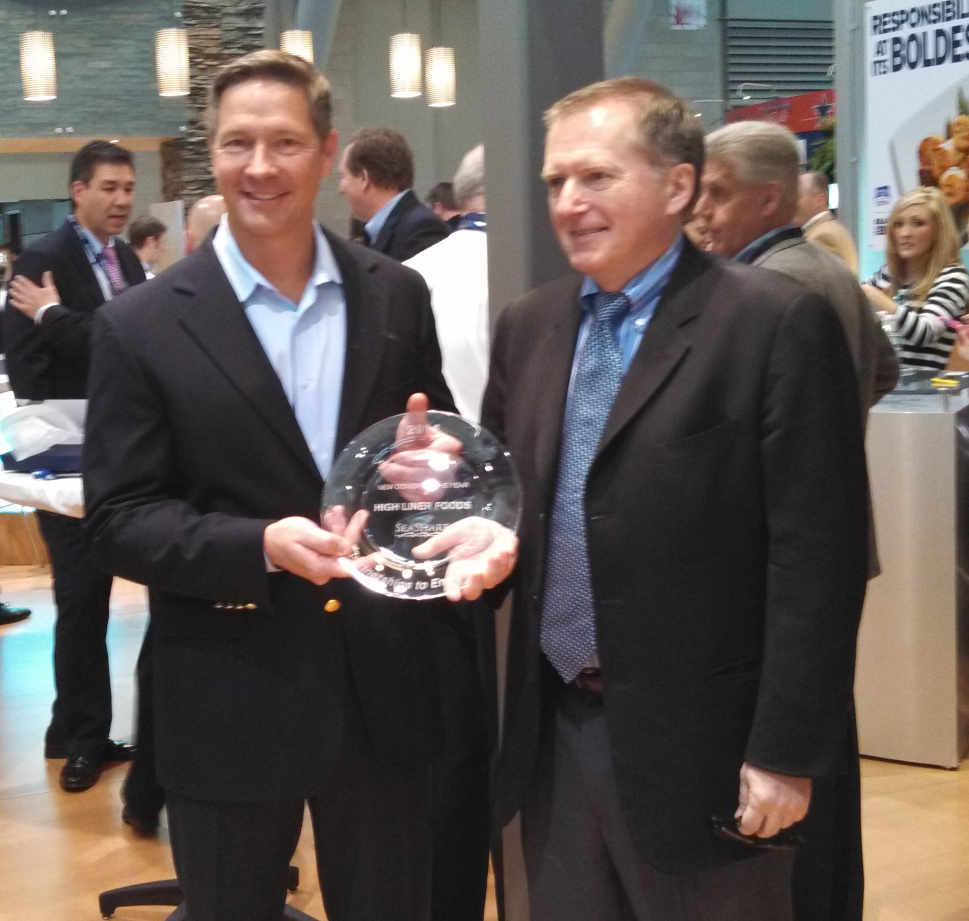

SeaShare’s unique model combines donations of fish with processing, packaging, storage, and financial support. High Liner is an important partner. This spring they are turning 200,000 pounds of frozen fillet blocks into retail-type, breaded and frozen portions. Thank you to the At-Sea Processors for donating the fish…. Over 3.5 million pounds since 2001.

New Partnerships: Of the 6 million seafood meals our donors generated last year, over 1 million seafood meals were distributed in Alaska. In order to reach more communities who want local, sustainable foods, SeaShare is working with strategic partners like Food Bank of Alaska, the Rasmuson Foundation, Alaska Marine Lines, and the Western Alaska Community Development Association. The transportation and storage of frozen food has always been a challenge within the state. We are assembling the right team of seafood donors, freight companies, philanthropists and academics, and community leaders to improve nutrition in remote villages. This is a long-term project, and SeaShare is excited to be part of it.

Spring is a busy time for our fishermen and processors. They know that good planning and preparation will pay off during the season. We are following their lead here at SeaShare. Our board has approved a new project to increase awareness and public support for seafood donations. We’ll be updating our published materials, and creating a fully responsive, mobile-

friendly website. Our goal is to align / connect the positive messages about seafood with the need for better nutrition for hungry families. We want to help our donors tell their stories. The public needs to know about the great work that our seafood and food bank partners do every day to help fight hunger in America. We want to compound your generosity with a larger network of like-minded philanthropists.

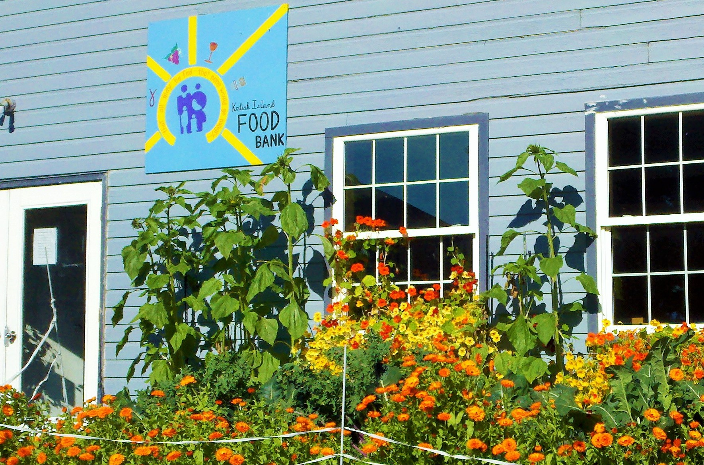

Food prices continue to rise. I read just today that protein items have increased 30% over the last 5 years. Sustainable seafood is an increasingly important food source for the world, and especially for hungry families. SeaShare uses seafood to feed people, change eating habits, and improve communities. Thank you for your help. Please contact us if you have questions about our current work, or if you have ideas for additional collaboration.
Best regards,
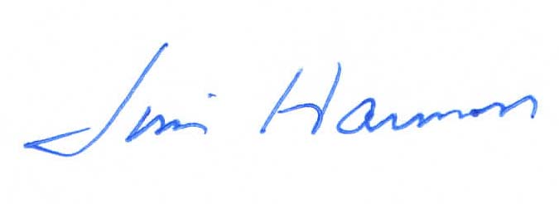
Jim Harmon
Executive Director

